**Name:** Yogesh Balasaheb Kumbhar. **Roll No: 56**

**Class:** Final Year B. Tech CSE **Batch:** B2

**Title:- Installation of Android SDK, emulator.**

**Step 1:** To Download the Android Studio, visit the official Android Studio Website in your Web Browser.

**Step 2:** Click on the “Download Android Studio” option.

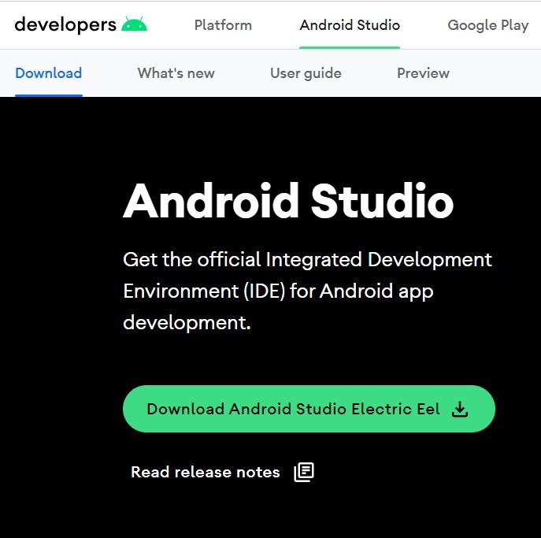

**Step 3:** Double click on the downloaded “Android Studio-ide.exe” file.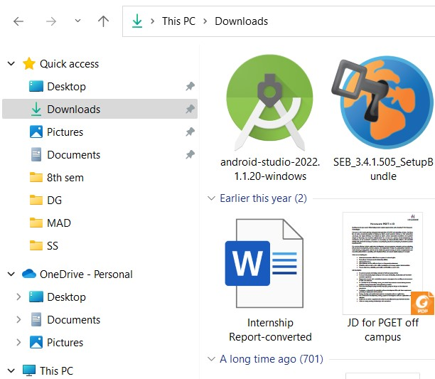

**Step 4:** “Android Studio Setup” will appear on the screen and click “Next” to proceed.

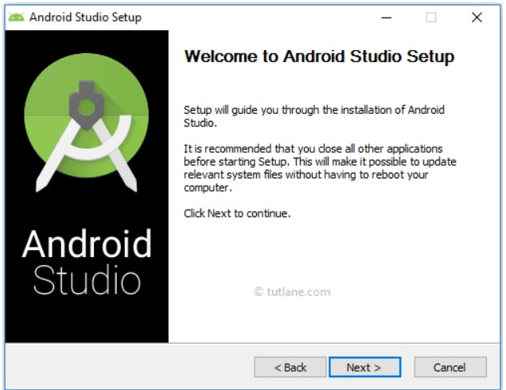

**Step 5:** Select the components that you want to install and click on the “Next” button.

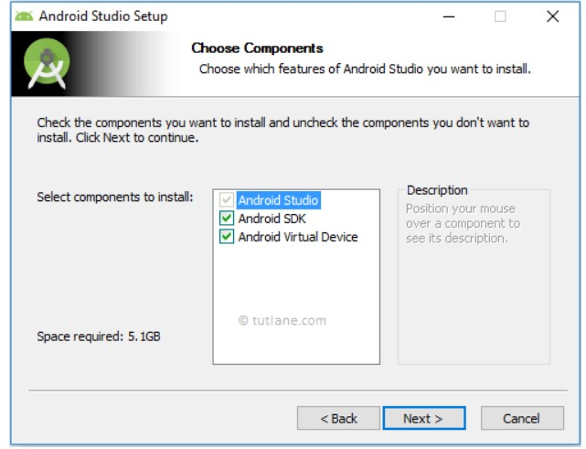

**Step 6:** Now,browse the location where you want to install the Android Studio and Click “Next” to proceed.

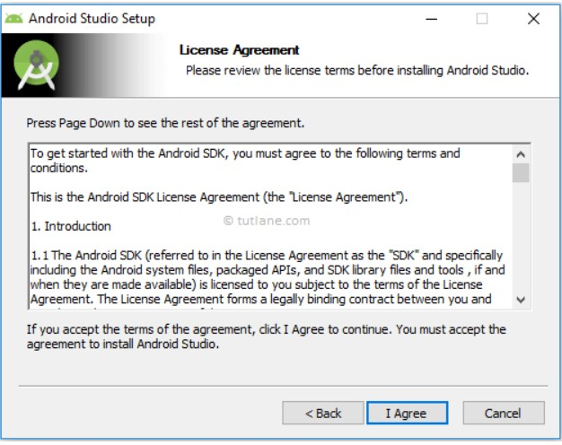

**Step 7:** Choose a start menu folder for the “Android Studio” shortcut and click the “Install” button to proceed.

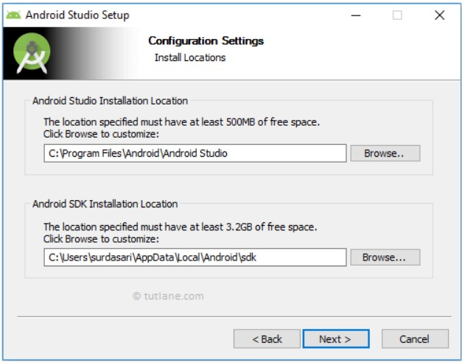

**Step 8:** After the successful completion of the installation, click on the "Next" button.

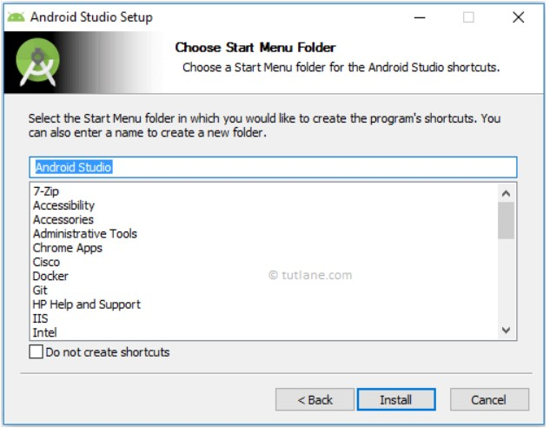

**Step 9:** Click on the "Finish" button to proceed.

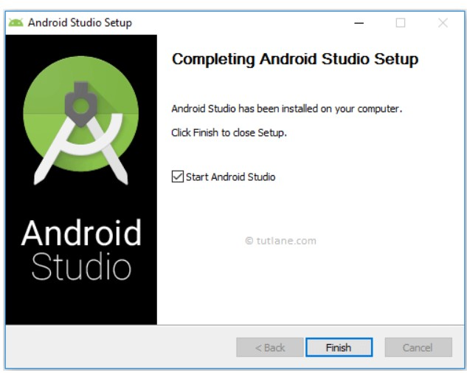

Now, your Android studio welcome screen will appear on the screen.

Android Studio Setup Configuration.

**Step 10:** "Android Studio Setup Wizard" will appear on the screen with the welcome wizard. Click on the "Next" button.

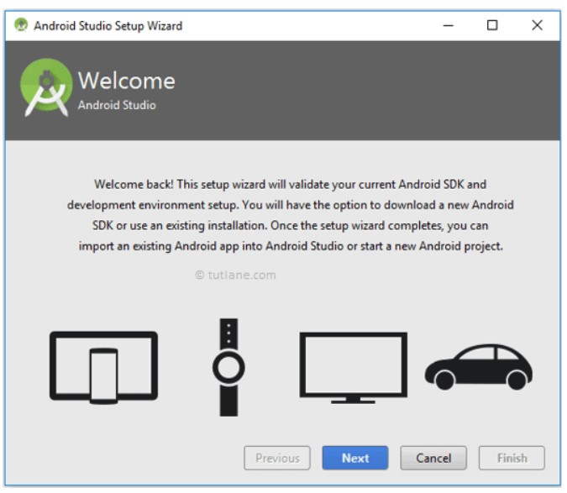

**Step 11:** Select (check) the "Standard" option if you are a beginner and do not have any idea about Android Studio It will install the most common settings and options for you Click "Next" proceed.

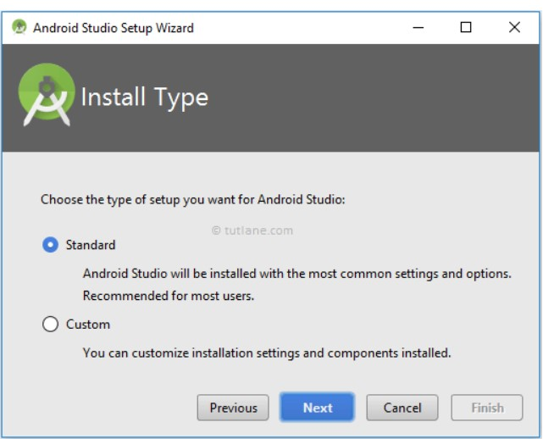

**Step 12:** Now, select the user interface theme as you want. (I prefer Dark theme (Dracula) that is most liked by the coders). Then, click on the "Next" button.

**Step 13:** Now, click on the "Finish" button to download all the SDK components. And, the downloading and installation process of components gets started.

**Step 14:** After downloading all the necessary components, click on the "Finish" button. The next step is to launch the emulator:

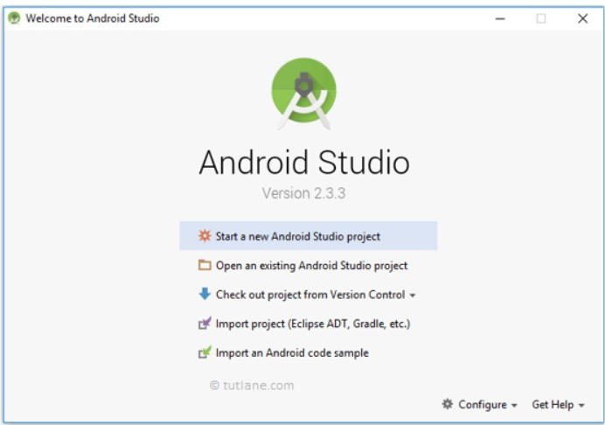

**Step 1:** Click on the AVD Manager button in the top-right corner of the screen.

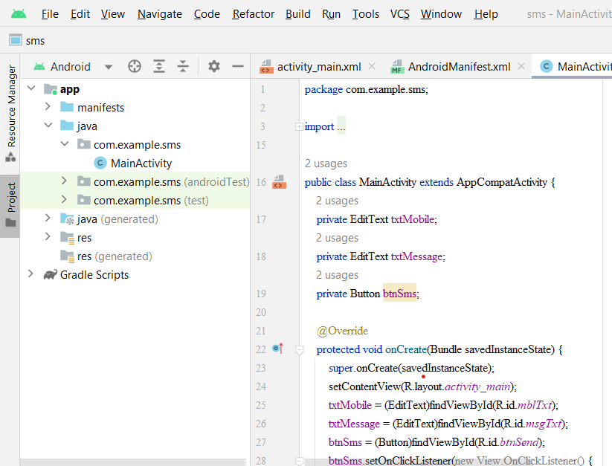

**Step 2:** You will see the emulator of the latest Android version. Click “Run”.

**Step 3:** At the bottom of the AVD Manager dialog box, click "Create Virtual Device"

**Step4:** Select the hardware profile for your emile and click "Next".

**Step 5:** Click on the "x86 system" tab and choose a system image. Note: System images in this section run the fastest in the emulator.

**Step 6:** Check your AVD configuration and click "Finish”.

**Step 7:** Select your AVD in the toolbar.

**Step 8:** Click the "Run" button next to the toolbar to start the emulator.